Daily Use – Upload System

Open Terminal and navigate to the peer js project folder.

Type the following in the terminal :
npm run start:development

You should see something like this :

> reability-peerjs@0.0.2 start:development /home/uzi/development/reability-peerjs
> NODE_ENV=development node app.js

You should always leave this terminal open !!!!
If you need the terminal, just open a new one.

Open the Reability Project in VS code

Open the following file: client/src/environments/environment.ts

Change the value of MY_IP to your ip and save (if you need)

const MY_IP = ‘192.168.10.97’ // Uzi Office ip

Open The vs code terminal (Ctrl-j) with 3 terminals.

Navigate to one of the new terminals and enter the following:
npm run start:server

You should see something like this at the end of the process:

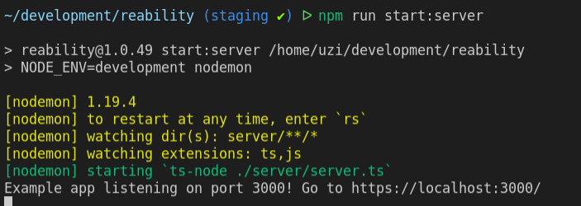

Navigate to the other terminal and enter the following

npm run start:client

You should see something like this :
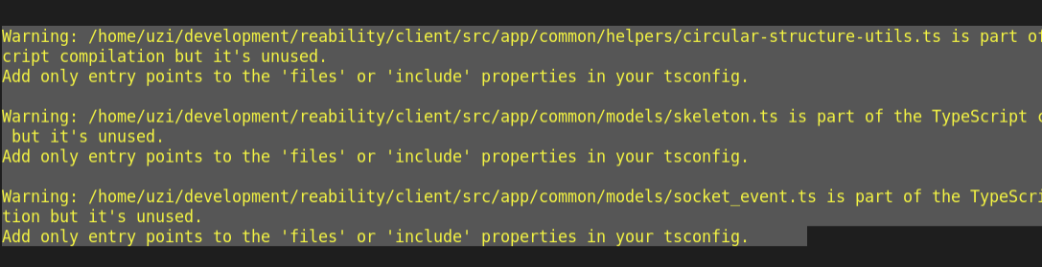

Open your web browser and navigate to the following address (Change the ip according to your ip)

https://192.168.10.97:8080/#/login

you should see the application login screen

Daily Use – Login Errors or Connection Not Private Page

Incase you can't make login although you have the correct credentials or get the "Your connection is not private" page when navigating to the login , do the following:

Open your browser and navigate to:
https://192.168.10.97:3001/
(Change the ip address according to your ip).

You should see the following :
Cannot GET /

If you see a message “Your connection is not private”
Click the “Advanced” button and then click on the link in the bottom of the screen that says “proceed to …..”

and then you should see the follwing
Cannot GET /

Open your web browser and navigate to the following address (Change the ip according to your ip)
https://192.168.10.97:8080/#/login

If you see a message “Your connection is not private”
Click the “Advanced” button and then click on the link in the bottom of the screen that says “proceed to …..”

and then you should see the application login screen

Daily Use – Switching Computer Location and IP Changes

Open Terminal and navigate to your development folder (where all your projects located).
Enter the following commands :

ip a

locate in the printed output your ip address (marked in yellow below) and write it down so you will remember it and also send to the project manager an email with your ip so he/she will be able to
enable you to run the app locally.

lo: <LOOPBACK,UP,LOWER_UP> mtu 65536 qdisc noqueue state UNKNOWN group default qlen 1000
link/loopback 00:00:00:00:00:00 brd 00:00:00:00:00:00
inet 127.0.0.1/8 scope host lo
valid_lft forever preferred_lft forever
inet6 ::1/128 scope host
valid_lft forever preferred_lft forever
2: enp1s0: <NO-CARRIER,BROADCAST,MULTICAST,UP> mtu 1500 qdisc fq_codel state DOWN group default qlen 1000
link/ether 68:f7:28:28:c6:55 brd ff:ff:ff:ff:ff:ff
3: wlp2s0: <BROADCAST,MULTICAST,UP,LOWER_UP> mtu 1500 qdisc noqueue state UP group default qlen 1000
link/ether d0:7e:35:3c:71:3e brd ff:ff:ff:ff:ff:ff
inet 192.168.10.97/24 brd 192.168.10.255 scope global dynamic noprefixroute wlp2s0
valid_lft 599509sec preferred_lft 599509sec
inet6 fe80::c8ae:3d4e:569a:b62a/64 scope link noprefixroute
valid_lft forever preferred_lft forever

Open the .env file in your peerjs project in a simple text editor.
Change the value of “REABILITY_URL” to your ip addresses and save the file

Open vs code in reability project and navigate to the .env file

Change the value of “SIGNALING_SERVER” to your ip addresses and save the file
SIGNALING_SERVER=192.168.10.97:3001

Change the value of “SERVER_URL” to your ip addresses and save the file
SERVER_URL=https://192.168.10.97:8080

Open the following file: client/src/environments/environment.ts

Change the value of MY_IP to your ip and save

const MY_IP = ‘192.168.10.97’ // Uzi Office ip

start the peerjs and reability projects

Open your browser and navigate to:
https://192.168.10.97:3001/
(Change the ip address according to your ip).

You should see the following :
Cannot GET /

If you see a message “Your connection is not private”
Click the “Advanced” button and then click on the link in the bottom of the screen that says “proceed to …..”

and then you should see the follwing
Cannot GET /

Open your web browser and navigate to the following address (Change the ip according to your ip)
https://192.168.10.97:8080/#/login

If you see a message “Your connection is not private”
Click the “Advanced” button and then click on the link in the bottom of the screen that says “proceed to …..”

and then you should see the application login screen.

